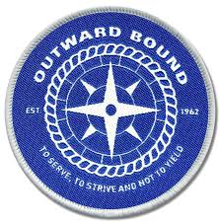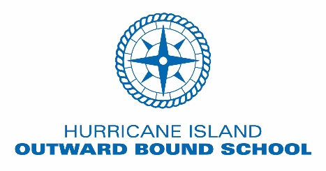



**ADK**

**Odyssey**



Outward Bound and Adirondack Odyssey

Participant Expectations

Students and school staff members considering applying for a scholarship from the Clark Sports Center Adventure Program should read through and be willing to commit to the following conditions.

Applicants/Participants must:

* Commit to the application requirements and deadlines shared by the Adventure Program staff and School Outward Bound Coordinators.
* Fully commit to course dates set for the following programs:
  + Adirondack Odyssey (2): July 12th – 19th ; August 2nd – 9th
  + Outward Bound Student Course: July 9th – 23rd
  + Outward Bound Educator Course: July 9th – 11th
* SCHOLARSHIP RECIPIENTS: must meet all health form deadlines as shared in your welcome letter from the Clark Sports Center Adventure Program.
* As a participant: share a willingness to challenge yourself socially, emotionally and physically while on course with your CREW members.
* Secure any necessary clothing/gear as outlined by the Clark Sports Center Adventure Program Staff and/or Outward-Bound requirements. Items needed to be acquired by participants are typically just personal clothing. Camping and canoeing type gear is provided. Questions and concerns regarding items needed should be directed to the Adventure Program staff.
* STUDENTS: Prepare in advance for the physical requirements of your course. Healthy eating and daily exercise starting well in advance of your course will improve your experience while on course in the Adirondacks or Maine.

I, ______________________________, agree to the scholarship conditions listed above and fully commit to the program I have applied to.

Signature: ___________________________________________ Date: / /

**Adirondack Odyssey**

Course Goals:

The purpose of this course is to further develop the leadership skills in the students that are selected and participate. This unique outdoor learning environment will challenge students to adapt and overcome a variety of diverse situations. Along the way they will work with the members of their CREW to improve their leadership skills as they relate to the characteristics listed below.



**ADK**

**Odyssey**



**Leadership Development:**

*Community Spirit:*

* Serves others for nothing more than appreciation

*There is No “I” in Team:*

* Builds up others; Works well in a team; Collaborates with CREW members for the benefit of the group

*Success Through Failure:*

* Learns from mistakes; Recognizes failure as a necessity to enter the “Learning Zone”

*Gratitude:*

* Appreciates what they have and works with it

*Strengths Based Mindset:*

* Understands everyone brings something to the table

**Outward Bound**

Course Goals:

**OUR MISSION & GOAL:**

Outward Bound’s mission is to change lives through challenge and discovery.

Our mission is predicated on the belief that values are experienced concretely rather than taught abstractly; that when the makeup of a crew crosses racial, economic or religious lines differences are celebrated, appreciated and valued.

It is predicated on the belief that we seek, embrace and value adventure and the lifelong adventure of learning.

We seek nothing less than to improve the lives of the students, parents, partners and the communities we serve and to approach every opportunity and challenge living our:



* Values of excellence
* Integrity
* Inclusion
* Above all, compassion . . . every day.